
Company
Logotype

Cone Beam Computed Tomography- Report



Porur Dental X-rays & CBCT

Patient Name : Mrs. Sobitha Ahila | Date of Report : 09.04.2024
Age/ Gender : 45 years/ Female | Region of Interest : CBCT Sectional Mandible
Referring doctor: Dr. I. Porkodi | Indication : Implant assessment
Clinical Notes: Nil
PATIENT INFORMATION

CBCT- Sectional Mandible provided
CBCT – IMAGE DETAILS

RADIOGRAPHIC INTERPRETATION

- In relation to 44, 45, 46, presence of restorative material in relation to the pulp canal extending upto the apical third of the roots is evident.
- Partial loss of crown structure in relation to 46 and root stumps 47, 48 are evident.
- The alveolar bone in relation to 46, 47 is present with normal trabecular pattern.

IMPLANT ASSESSMENT

 | 46 region | 47 region
Sub-Crestal (in mm) | 8.66 | 8.44
Mid- Crestal (in mm) | 9.45 | 10.48
Distance between alveolar ridge and the inferior alveolar nerve canal (in mm) | 16.11 | 13.96
Distance between alveolar ridge and the inferior border of mandible (in mm) | 26.81 | 27.8

RADIOGRAPHIC IMPRESSION

- Fractured crown: 46
- Root stumps: 47, 48

Kindly correlate with clinical findings


IMAGES FOR REFERENCE

RECONSTRUCTED PANORAMIC VIEW

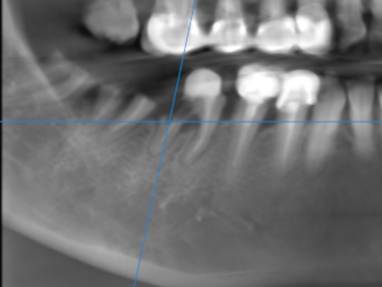

3-DIMENSIONAL VIEW

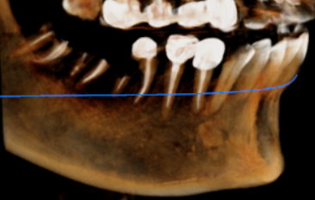

CROSS SECTIONAL VIEW

46 region | 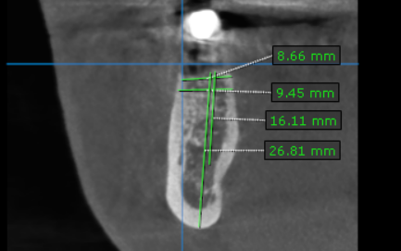
47 region | 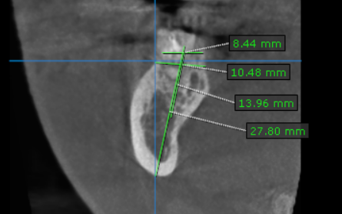

**** End of report ****

